Chicago Skyline with Buildings Labeled

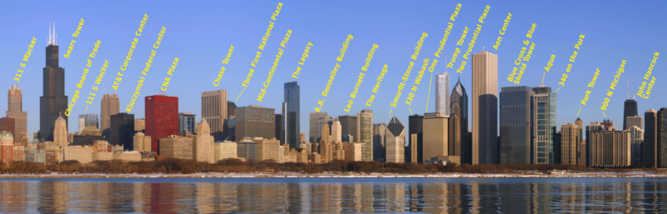
Chicago skyline view from Adler Planetarium, 19 February 2010, labeled
Author: Peter Fitzgerald, photographer: J. Crocker
From: https://commons.wikimedia.org/wiki/File:Adler_Planetarium_skyline_view_labeled.png

